***RESTRAU DE GRANDE***

***Restaurant and Caterers***

***EST 1940***

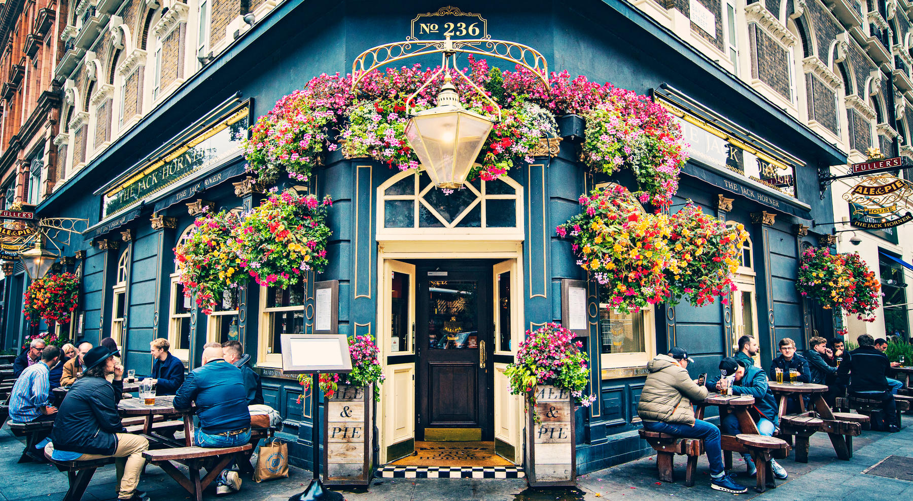

***Restaurant Menu Card***